How to fly the Crazyflies

1. Get Linux running on your machine, dual boot or full install (please don’t use docker or a vm it makes everything so much worse)
2. Install tmux through terminal so you can run multiple commands at once in the same window
3. Install python3 and pip (if pip doesn’t work you can – force break system packages )
4. Install Ros2 Jazzy

<https://docs.ros.org/en/jazzy/Installation.html>

1. Install all the bitcraze python client

<https://www.bitcraze.io/documentation/repository/crazyflie-clients-python/master/installation/install/#installing-from-latest-release>

(make sure to update the usb permissions like it says and install the firmware for the crazyradio)

1. Clone the crazyswarm2 repo somewhere onto your computer (super useful to copy code from their /crazyflie_examples folder. Don’t put it in a nested github repository just keep a local version somewhere else

<https://github.com/IMRCLab/crazyswarm2>

1. Plug in a crazyradio and turn on one of the crazyflies (use #1 to start), the on button is kind of hard to find its around here

***HOLD THE CRAZYFLIE IN ONE HAND THEY WILL TAKE OFF AND HIT THE CEILING*****

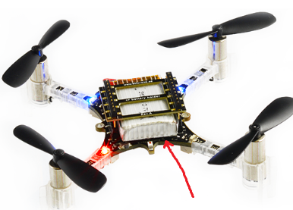

1. Launch the bitcraze python client and hit the search button in the top left, you should be able to connect to the #1 crazyflie if it’s on (see light codes sheet I wrote). If you connected correctly you should be able to see the crazyflie’s bad state estimation when you move it around with your hand
2. Open the crazyflies.yaml file from the crazyswarm2 repo, this will have a list of all of the crazylflie’s unique identities for the radio to talk to them with
3. In the bitcraze client once you’re connected to the crazyflie you can update its parameters like its id number so that it can be seen in the yaml file. This is useful for when you are doing a swarm because they all have the same initial value, but you have to do it one at a time with the client.
4. Now that it’s configured, make sure that the id it has matches the yaml, and that the yaml has only 1 crazyflie listed that’s not commented out. You can close the client when you’re done configuring.
5. Launch a new terminal and start tmux so that you can see a bunch of terminals at once
6. Run the launch file, this will start the crazyradio communication with the crazyflie. Wait until that terminal reads that everything is connected. Once this is running you can either send commands directly through another terminal on the right topic, or you can run a python file (better) to control the drones. Try this one

ros2 launch crazyflie_examples keyboard_velmux_launch.py

1. Now try running one of the examples, this is where you put the actual code that will run on the crazyflies. Put this in a new terminal while the launch file is still running!

ros2 run crazyflie_examples hello_world.py

1. That should take off the first one (or at least try, up to this point they haven’t been able to estimate their own states accurately so they usually crash. Hopefully you have the motion capture system now so that they stop that. You’ll have to do a bit of set up for the motion capture system but that’s documented in crazyswarm2
2. Write your own code and run it! Using that same launch file is helpful for the beginning, and you can run through the whole swarm as an array to control them all at once if you update the yaml to include them.